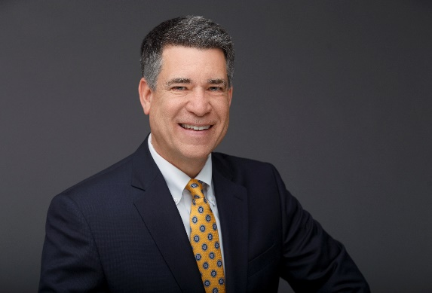 | CURRICULUM VITAE  John S. Addams  Niddrie Addams Fuller Singh LLP  225 Broadway, 21st Floor (619) 238-6065  jaddams@appealfirm.com

John is certified as a specialist in appellate law by the California State Bar Board of Legal Specialization, a distinction earned by only 1% of his California peers. Having successfully first-chaired several jury and bench trials, John brings a unique combination of skill, experience, and perspective to the appellate arena. He has more than 30 years of experience handling civil appeals in state and federal courts in a wide range of practice areas, including business and real estate disputes, employment litigation, class actions, probate litigation, insurance coverage and bad faith, elder law, and personal injury. Trial counsel throughout California also seek John out because of his litigation background to assist with critical motion practice and develop an appellate-friendly trail strategy. John is licensed in California, Nevada, and Arizona.
John began his career at Wingert, Grebing, Anello and Brubaker LLP, a prominent litigation firm in San Diego. As a partner, John chaired the firm’s insurance coverage and appellate practice groups. He then established the Law Offices of John S. Addams, where he expanded his appellate practice.
At Niddrie Addams Fuller Singh LLP, an appellate boutique firm, John enjoys the freedom to devote his very best effort to every case. For each client, he conducts thorough research, meticulously crafts compelling writings, provides persuasive oral advocacy, and offers cost-effective case strategies. John’s clients also benefit from the collective experience of the firm’s other members. The firm has been recognized as one of the top appellate boutiques in California by the Daily Journal.
Certified Specialty
2012 Certified as a Specialist in Appellate Law by the California State Bar Board of Legal Specialization
Education
1989 Ohio State University, Moritz College of Law
Juris Doctor, Articles Editor, Ohio State Journal on Dispute Resolution
1985 Ohio State University
B.A., Communications

Published Decisions
Leger v. R.A.C. Rolling Hills L.P. (2022) 84 Cal.App.5th 240
Collins v. County of San Diego (2021) 60 Cal.App.5th 1035
Lee v. Kotyluk (2021) 59 Cal.App.5th 719
Severin Mobile Towing, Inc. v. JPMorgan Chase Bank, NA (2021) 65 Cal.App.5th 292
Usher v. White (2021) 64 Cal.App.5th 883
Golden Eagle Land Investment v. Rancho Santa Fe Assn. (2018) 19 Cal.App.5th 399
Brinkley v. Monterey Financial Services, Inc. (2015) 242 Cal.App.4th 314
Ukkestad v. RBS Asset Finance, Inc. (2015) 235 Cal.App.4th 156
Muldrow v. Surrex Solutions (2012) 146 Cal.Rptr.3d 447
Munn v. Briggs (2010) 185 Cal.App.4th 578
Photomedex, Inc. v. Irwin, 601 F.3d 919 (2010)

Dobron v. Bunch, 125 Nev. 36, 215 P.3d 35 (2009)
Mediplex of California v. Superior Court (1995) 34 Cal.App.4th 748
Leadership, Service to the Legal Community, and Volunteer Work
San Diego Appellate Inn of Court
Master (2018-present)
Lopardo Inn of Court
Master (2015-present)
San Diego Civil Appellate Self-Help Workshop
Volunteer (2016-present)
Conference of California Bar Associations
Delegate (1992-1993)
Professional Awards and Recognitions
Super Lawyers®, Appellate Law (2013-present)
San Diego Magazine Top Appellate Lawyers (2013-present)
AV® Preeminent Peer Review Rated, Martindale-Judicial Edition (2010-present)
Semi-Finalist, San Diego Daily Transcript Top Insurance Law Lawyers (2011)
Certificate of Recognition, San Diego Teen Court (2008)

Recent Speaking Engagements
Top 25 Tips for Civil Appeals, La Jolla Bar Association, 11/2018
Co-Team Leader, Dispositions, San Diego Appellate Inn of Court, 10/2019
Co-Team Leader, Practicing During Covid-19, Lopardo Inn of Court, 12/2020
Team Leader, Multigenerational Practice of Law, Lopardo Inn of Court, 5/2022
Recent Publications
“Upping Your Game: How to Write an Exceptional Appellate Brief,” North County Lawyer, October/November 2022
References Available Upon Request

